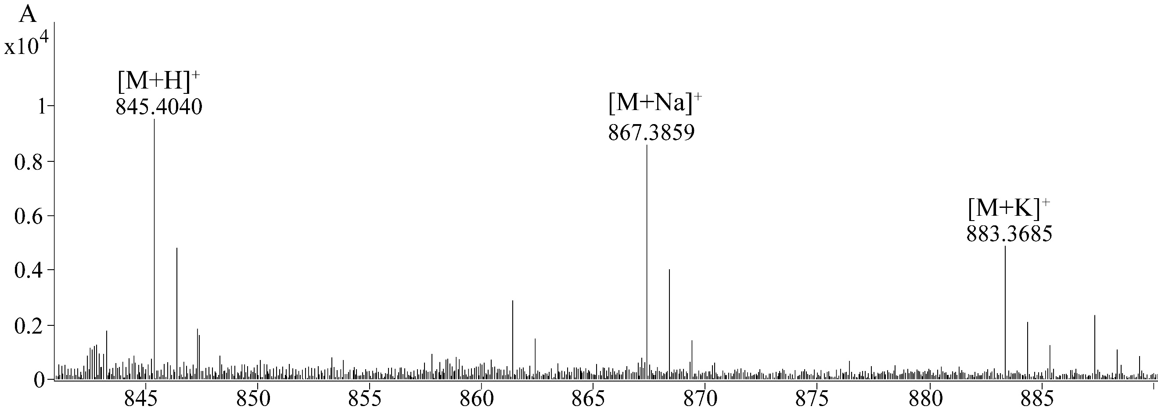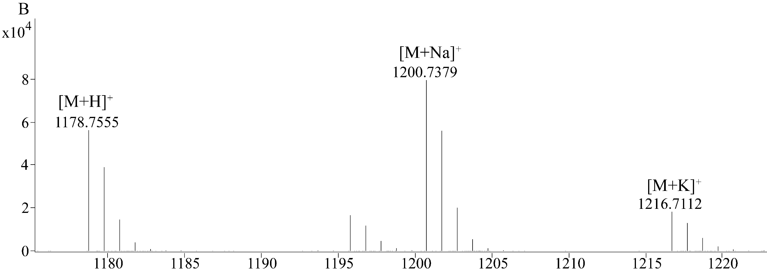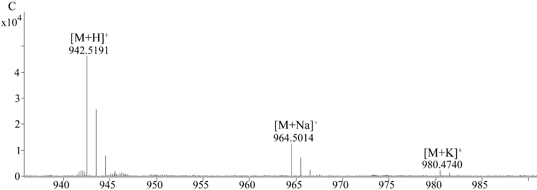
Fig. S1. The monoisotopic masses of candidate new cyclic peptides in Amanita rimosa. The three molecules corresponded to the cyclized core peptide sequences of ISDPTAYP (A), FIPLGIITILP (B) and FPTRPVFP (C). The adduct ions of [M+Na]⁺ and [M+K]⁺ were shown in each figure.

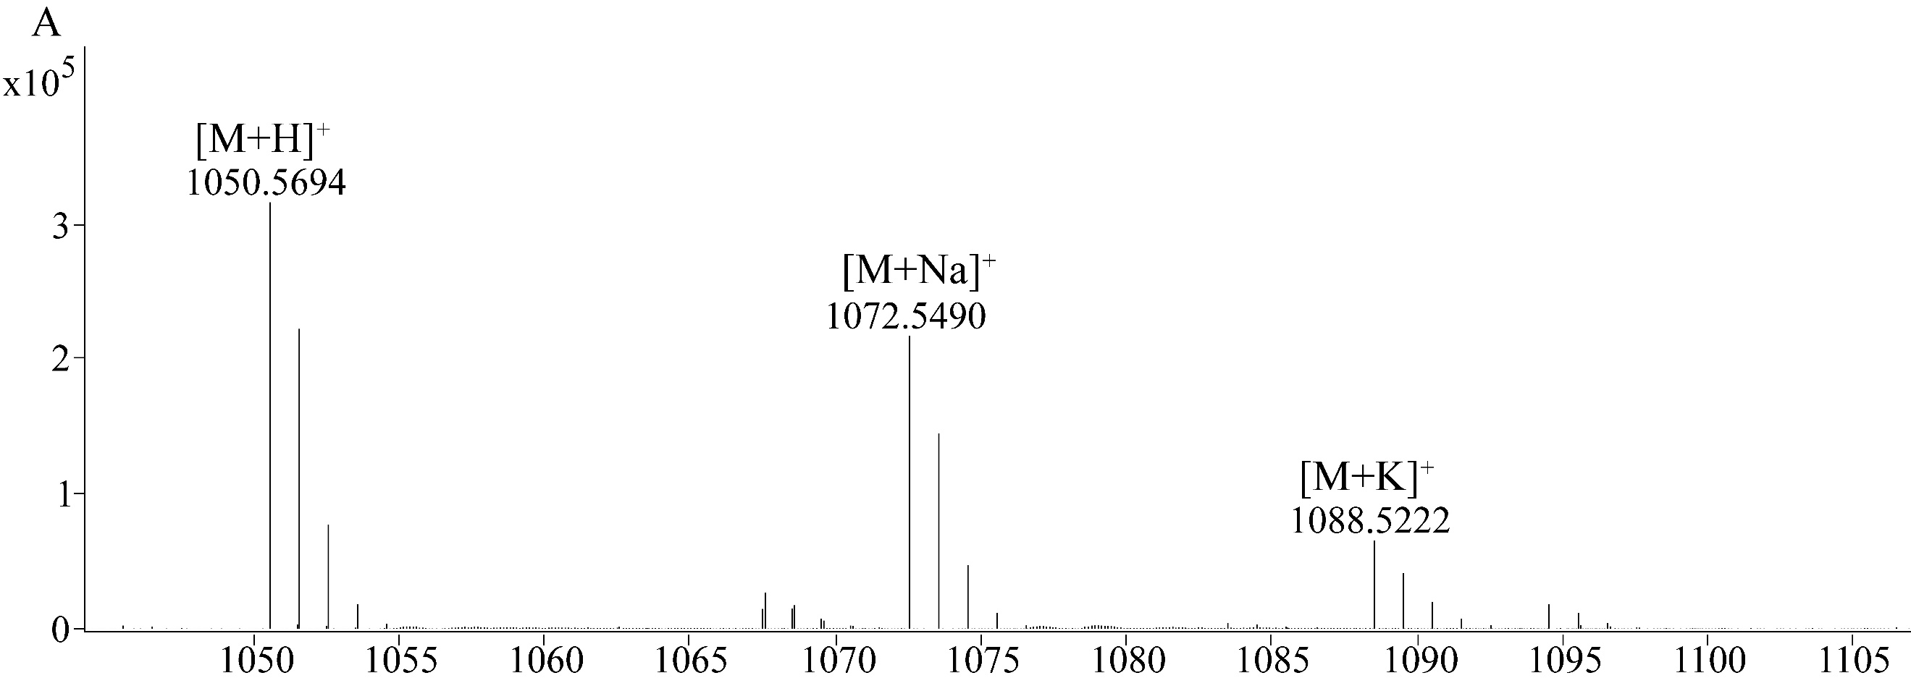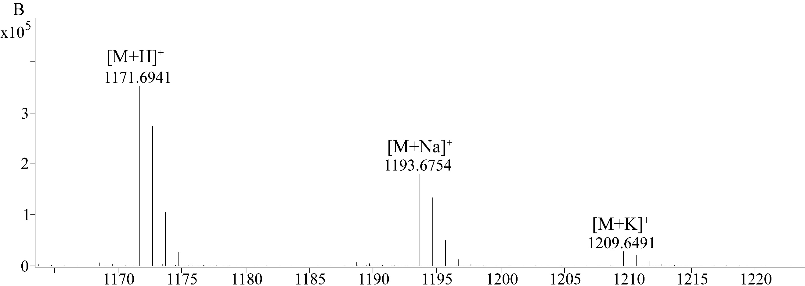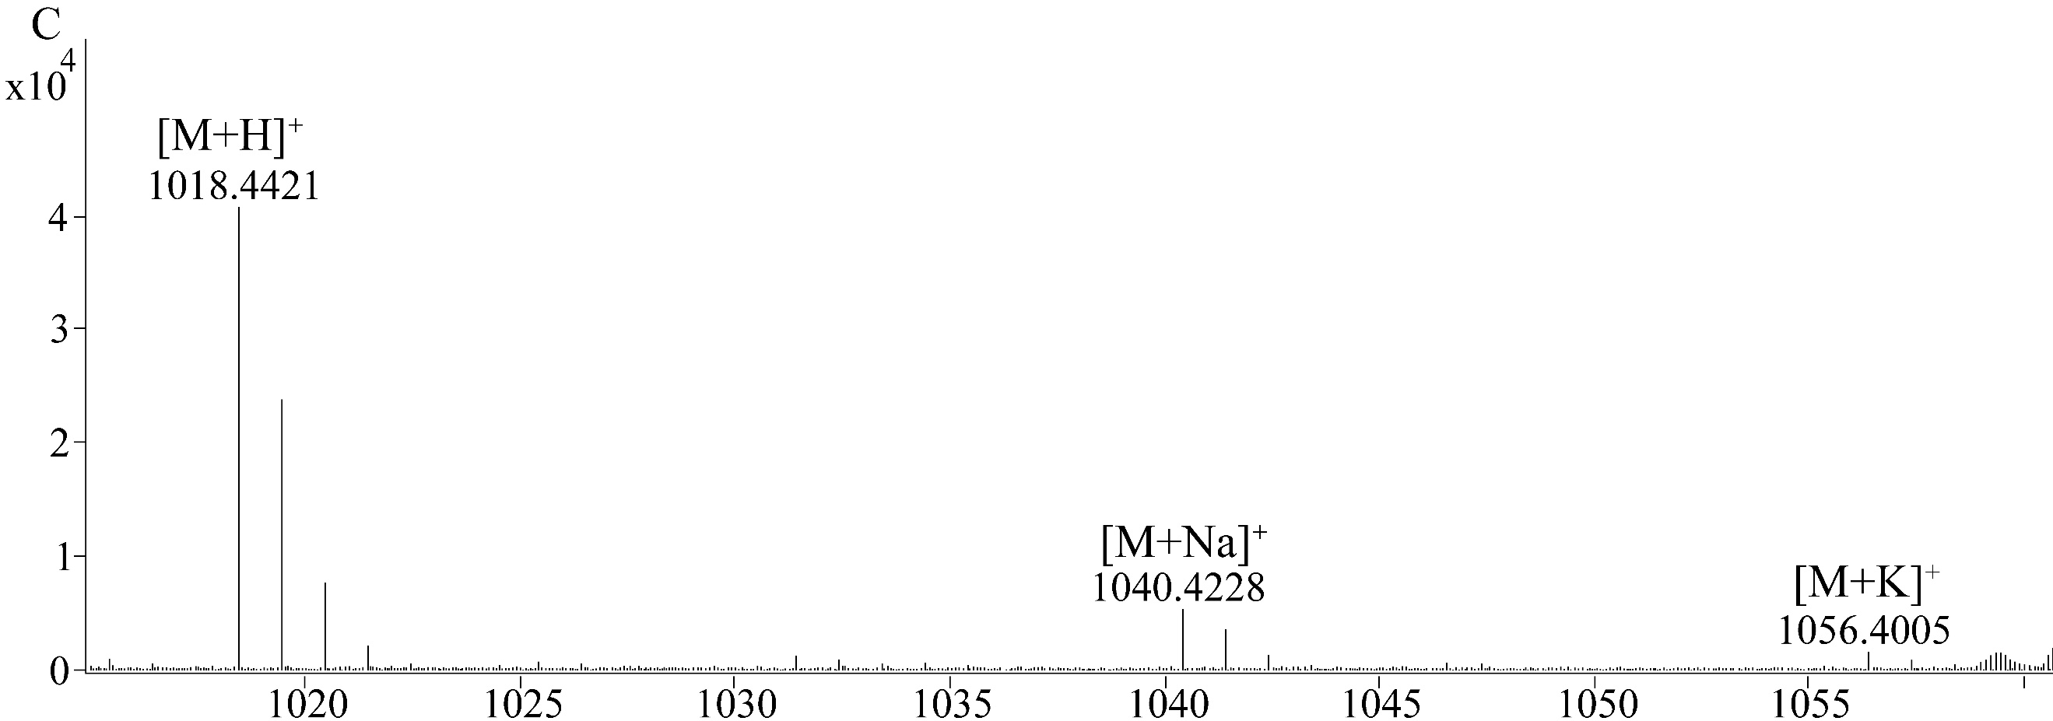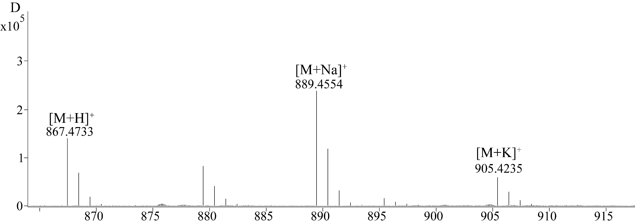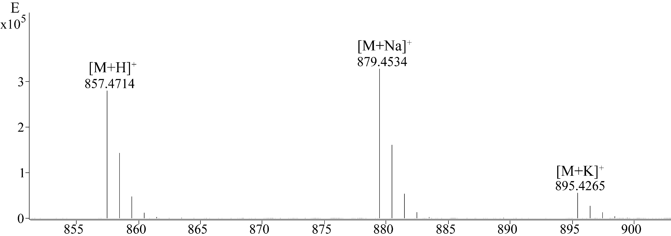
Fig. S2. The monoisotopic masses of candidate new cyclic peptides in Amanita pallidorosea. The five molecules corresponded to the cyclized core peptide sequences of EFIVFGIFP (A), FVIIPPFIFP (B), YFFNDHPP (C), TIHLFSAP (D), and MHILAPPP (E). The adduct ions of [M+Na]⁺ and [M+K]⁺ were shown in each figure.
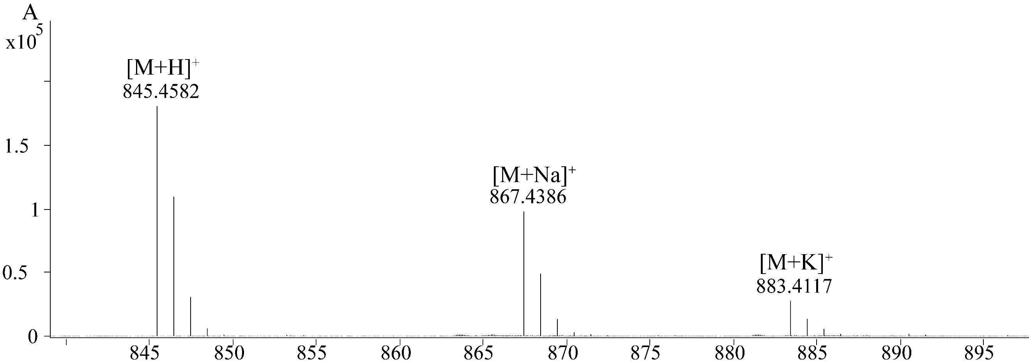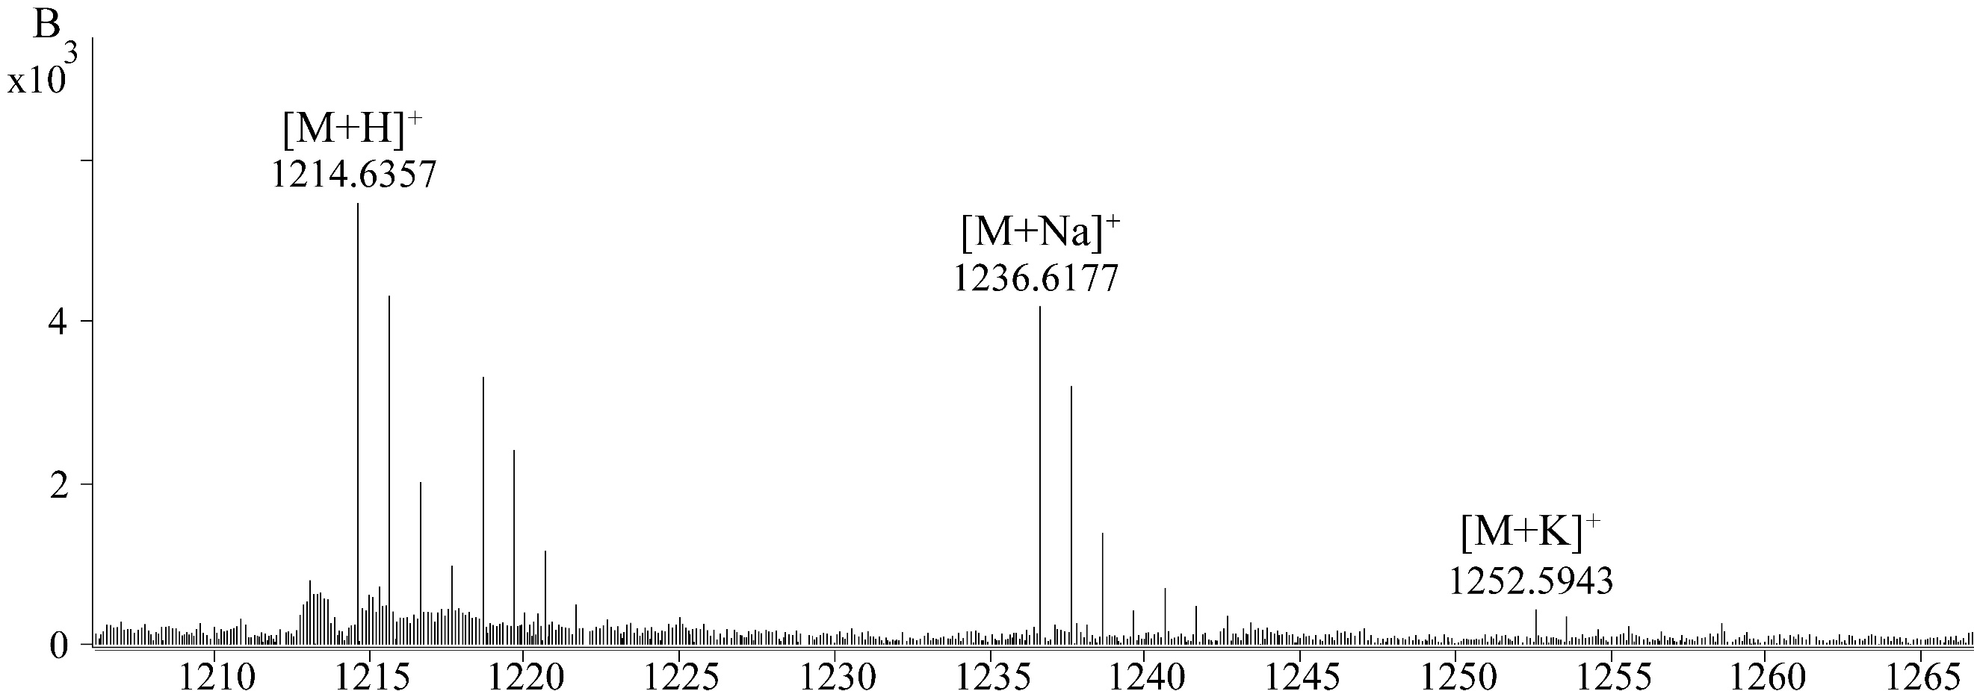
Fig. S3. The monoisotopic masses of candidate new cyclic peptide in Amanita exitialis. The two molecules corresponded to the cyclized core peptide sequences of FVFVASPP (A) and LFFPPDFRPP (B). The adduct ions of [M+Na]⁺ and [M+K]⁺ were shown in each figure.

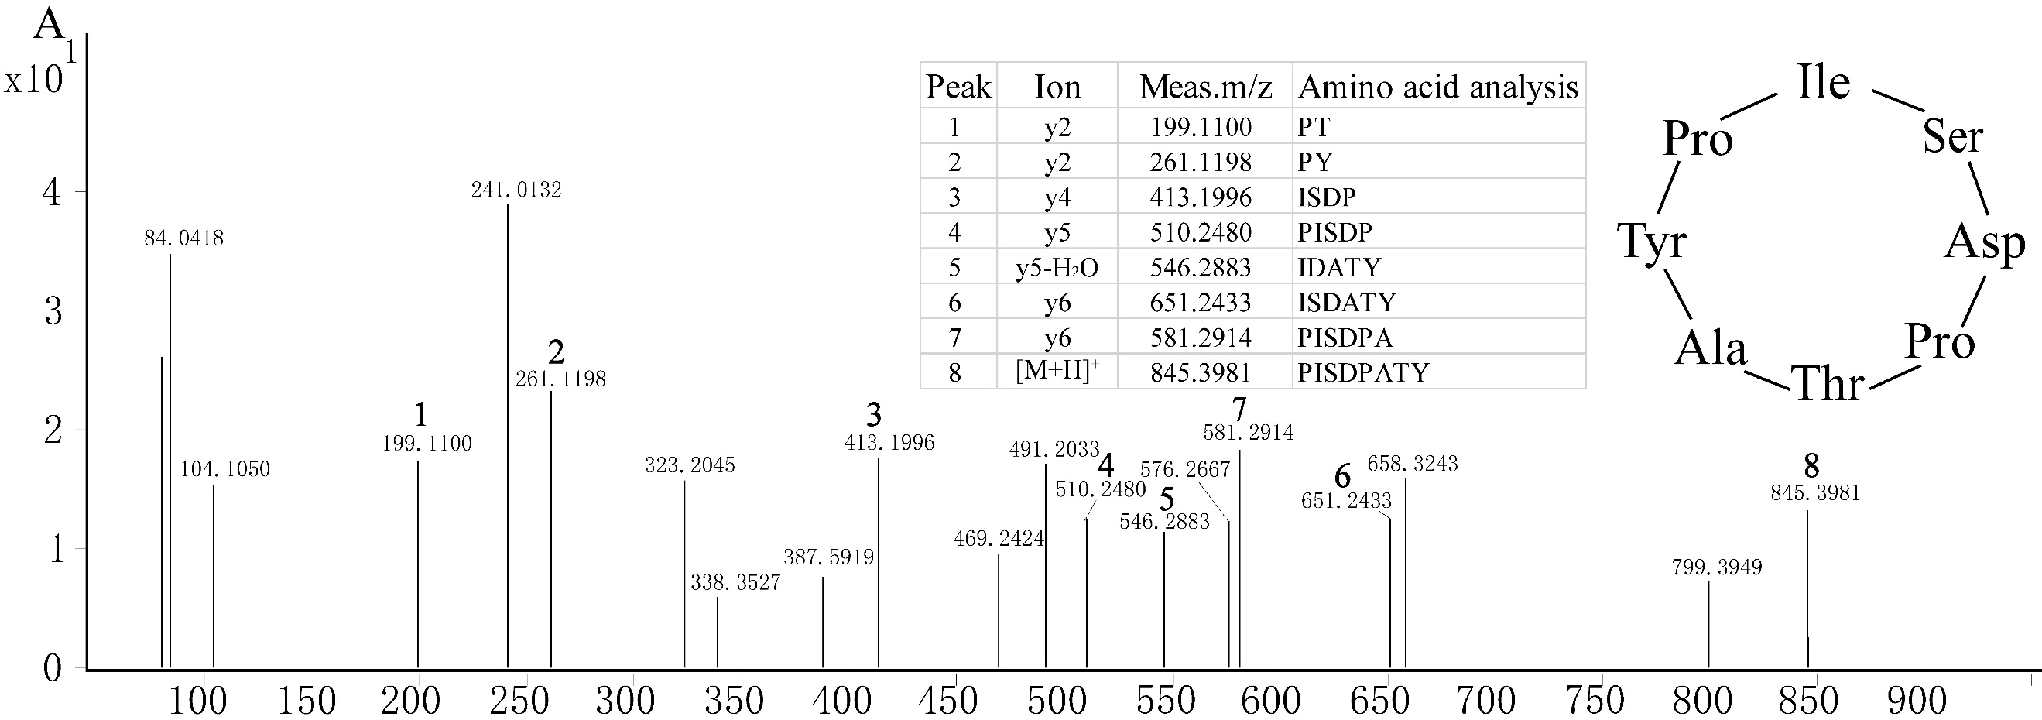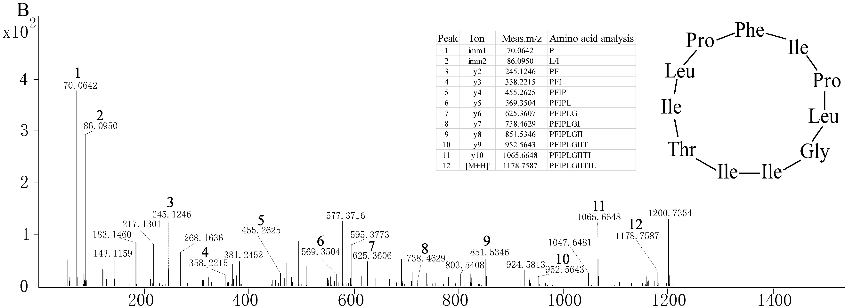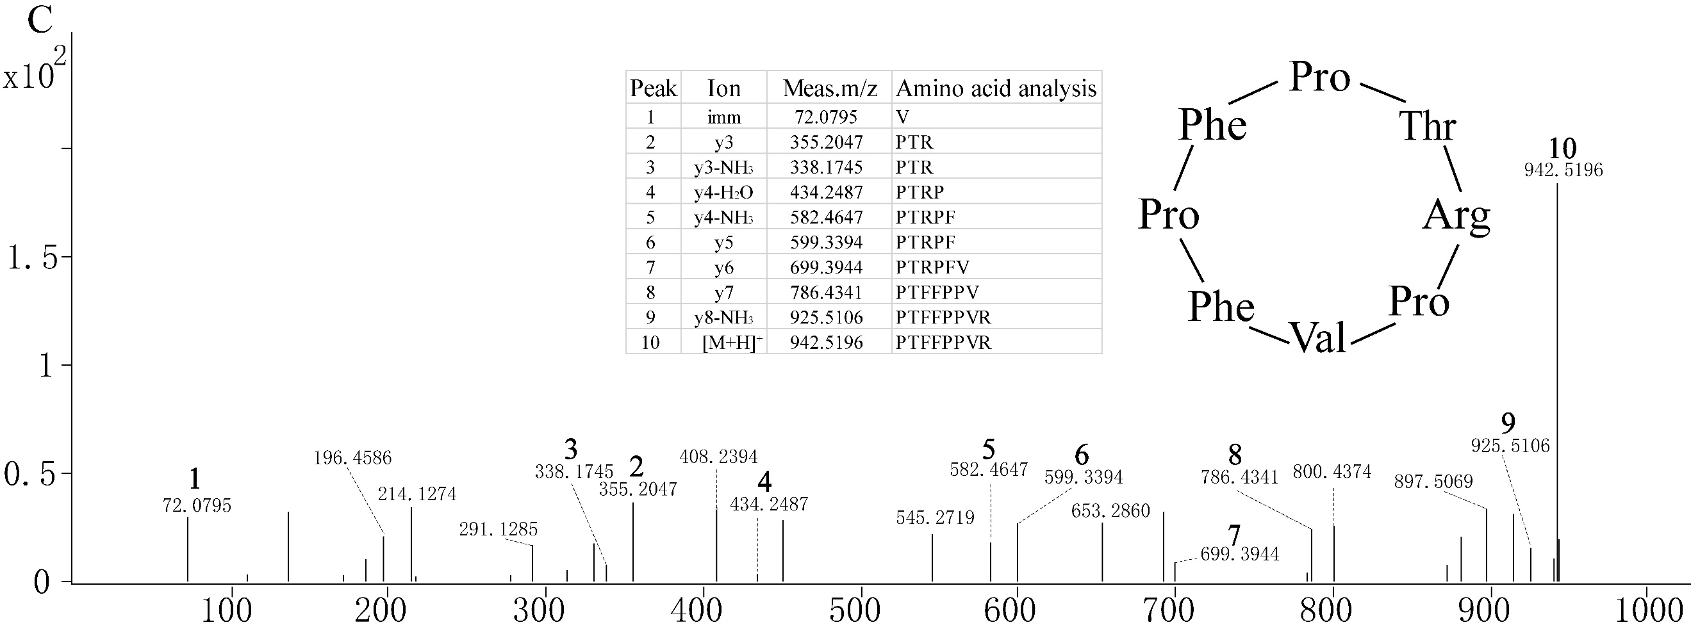
Fig. S4. Tandem mass spectrometry of novel cyclic peptides in Amanita rimosa. Manual analysis of amino acid compositions of Cyclo(ISDPTAYP) (A), Cyclo(FIPLGIITILP) (B) and Cyclo(FPTRPVFP) (C), with inserted tables of matched amino acids; immonium ions were shown when present. The determined cyclic peptides were shown as circles.

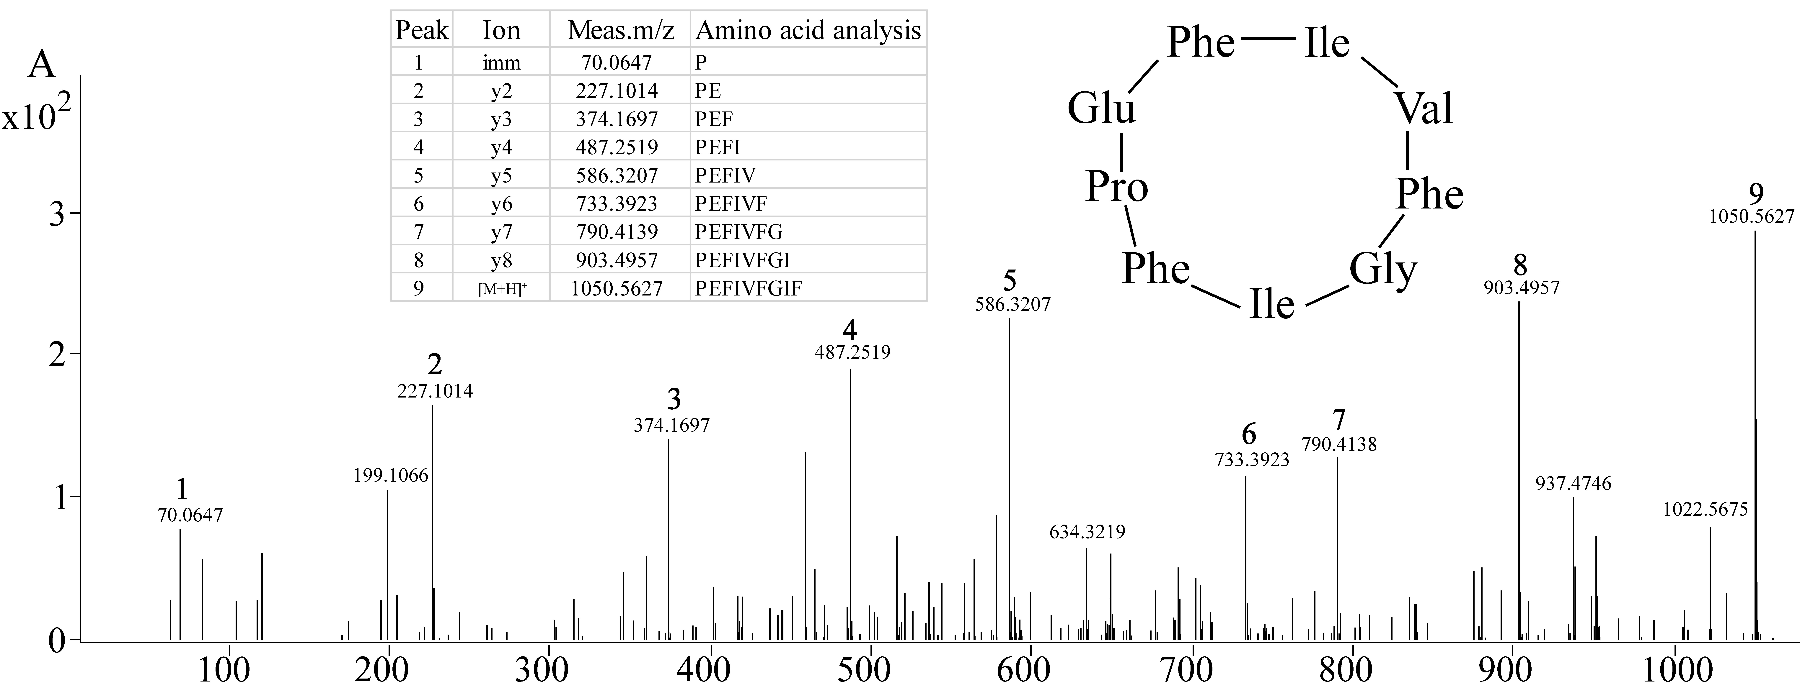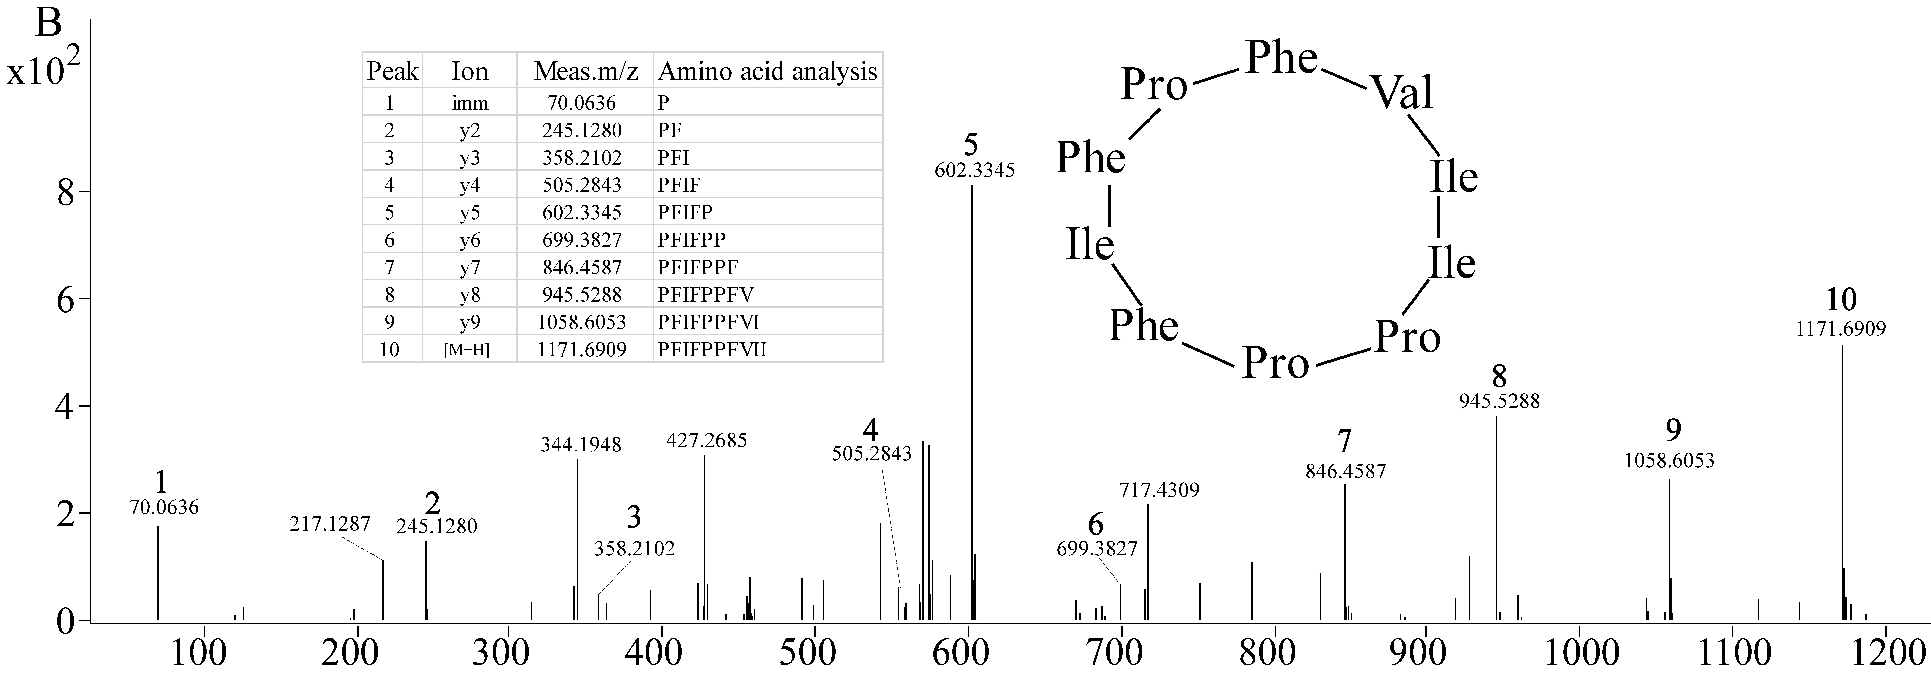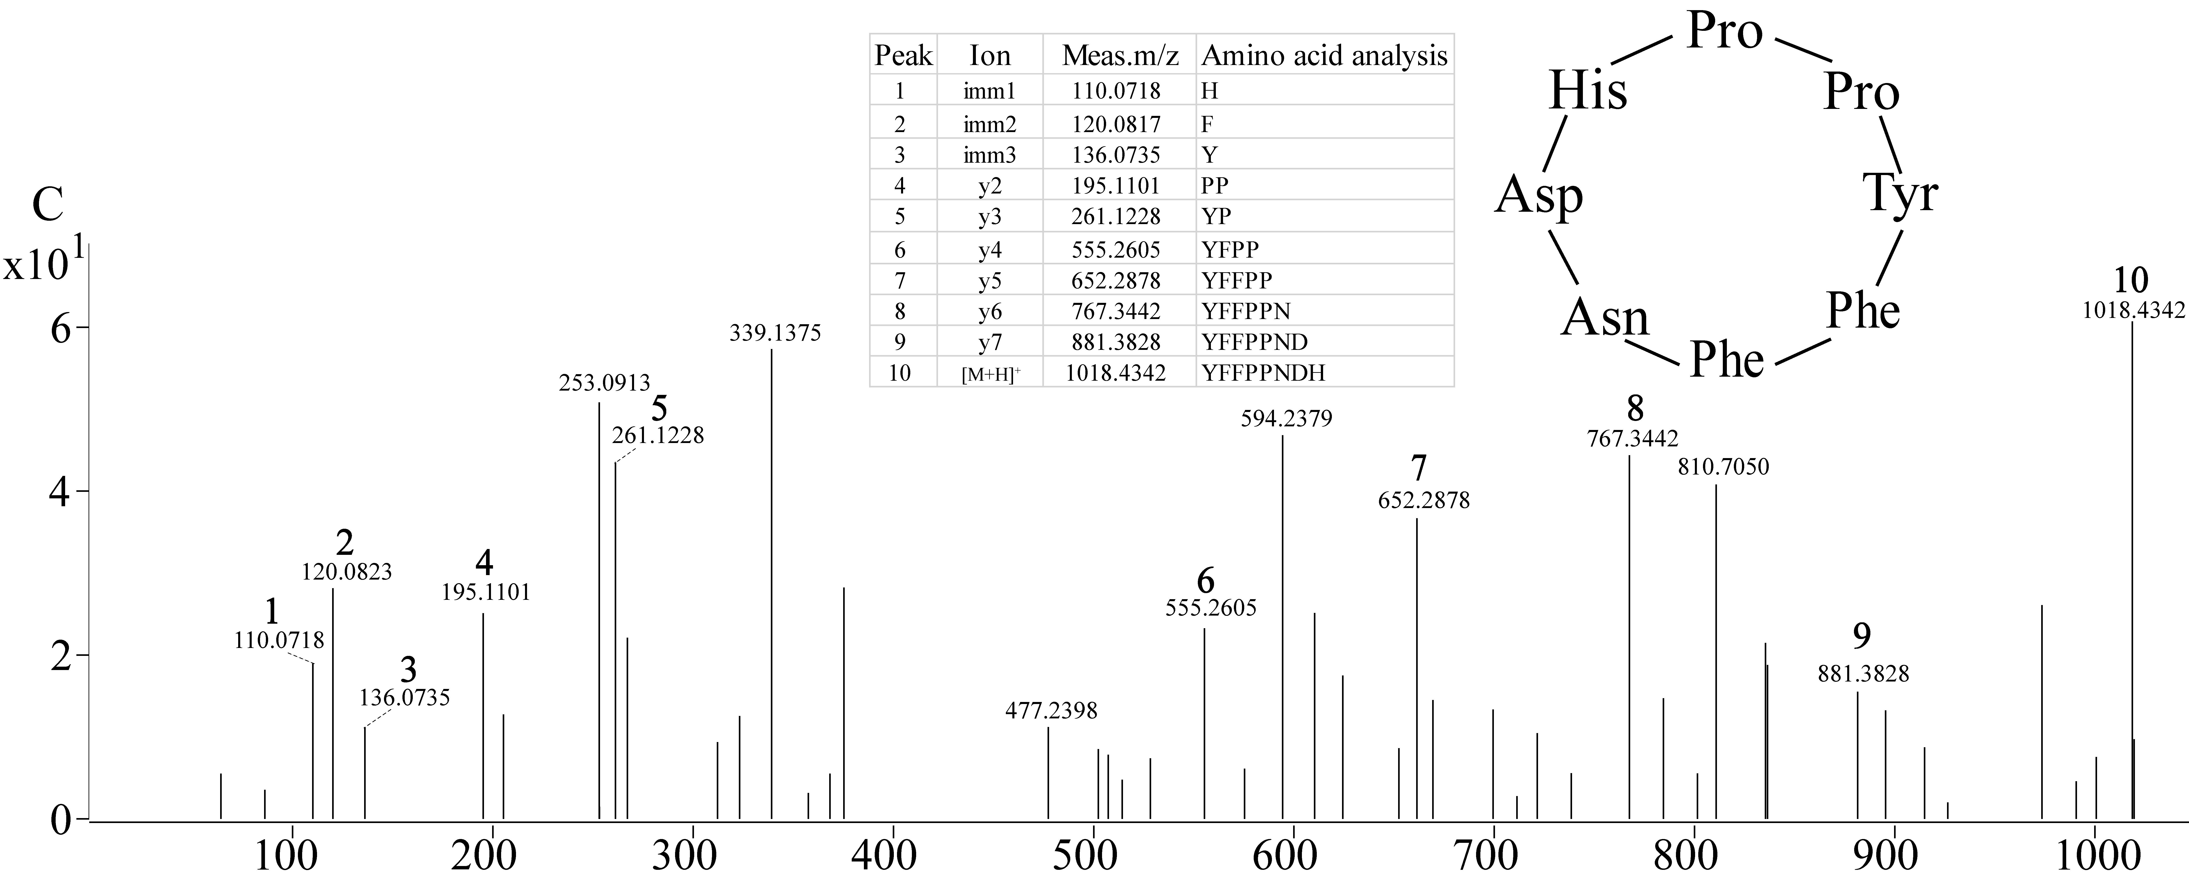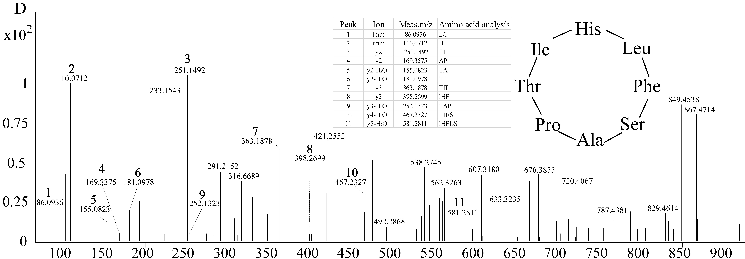
Fig. S5. Tandem mass spectrometry of novel cyclic peptides in Amanita pallidorosea. Manual analysis of amino acid compositions of Cyclo(EFIVFGIFP) (A), Cyclo(FVIIPPFIFP) (B), Cyclo(YFFNDHPP) (C), Cyclo(TIHLFSAP) (D), and Cyclo(MHILAPPP) (E), with inserted tables of matched amino acids; immonium ions were shown when present. The determined cyclic peptides were shown as circles.

Fig. S6. Tandem mass spectrometry of novel cyclic peptides in Amanita exitialis. Manual analysis of amino acid compositions of Cyclo(FVFVASPP) (A) and Cyclo(LFFPPDFRPP) (B), with inserted tables of matched amino acids; immonium ions were shown when present. The determined cyclic peptides were shown as circles.
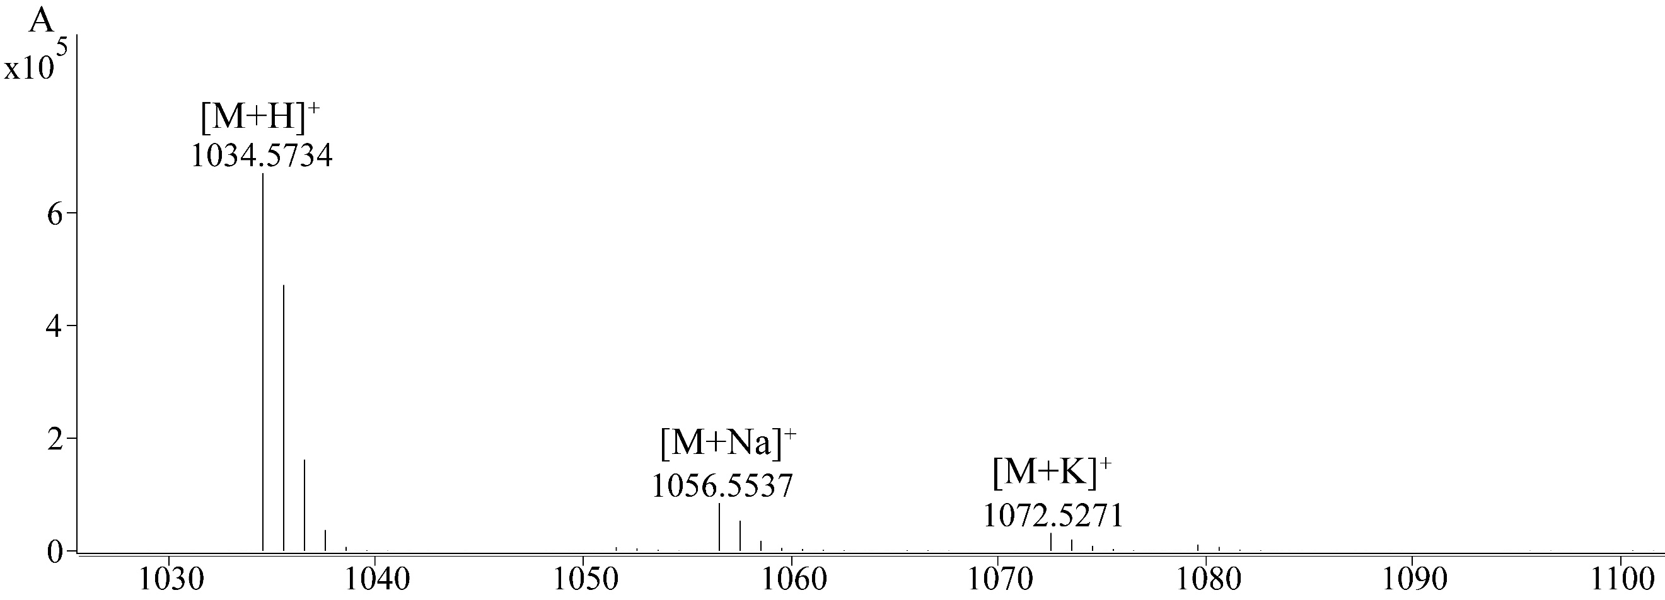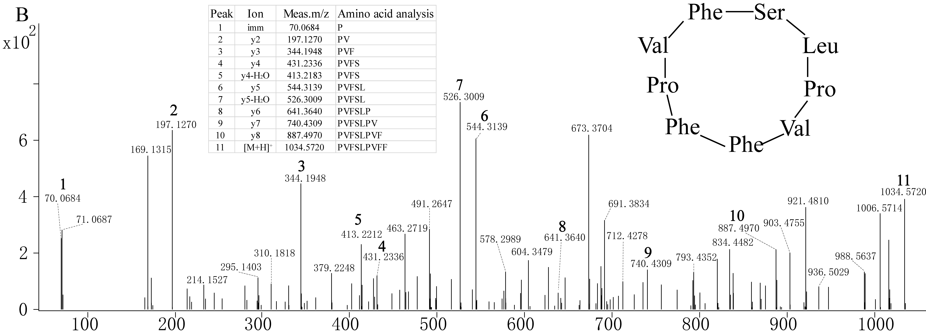
Fig. S7. Mass spectrometry of Amanexitide from Amanita exitialis. (A) The molecule corresponded to amanexitide was shown with adduct ions. (B) Manual analysis of amino acid composition of amanexitide with inserted tables of matched amino acids; immonium ions were shown when present. The determined cyclic peptide was shown as a circle.

Table S1. MSDIN family and novel cyclic peptides in Amanita pallidorosea
Leader Peptide | Core Peptide | Peptide Recognition Sequence | Monoisotopic Mass
MSDINATRLP | IWGIGCNP | CVGDEVTALITRGEA | 918.3541（α-amanitin）
MSDINATRLP | IWGIGCNP | CVGDEVAALLTRGEA | 918.3541（α-amanitin）
MSDINATRLP | IWGIGCDP | CVGDDVTGVLTRGEA | 919.3382（β-amanitin）
MSDVNATRLP | AWLVDCP | CVGDDINRLLTRGEK | 846.3217（phallacidin）
MSDINATRLP | AWLMTCP | CVGDDVNPTLTRGE | 802.3578
MSDINASRLP | AWLATCP | CAGDDVNPTLTRGE | 788.3160（phalloidin）
MSDINATRLP | DPRRLLIP | GGSDDVDSALTRDE | 960.5941
MSDINTARLP | EFIVFGIFP★ | CVGDDIQTVLTRGE | 1049.5658
MSDINASRLP | FFPEVGFFP | CVGDDTNPILTRG | 1067.5189
MSDINTIRVP | FPWTGPFVP | CVGDDVGSVLTHGE | 1028.5192
MSDINTARLP | FVIIPPFIFP★ | CVSDDIEMVLTRGE | 1170.6914
MSDINATRLP | HPFPLGLQP | CAGDVDNLTLTRGE | 986.5410
MSDINATRLP | HPFPLGLQP | CAGDVDNLTLTRGE | 986.5410
MSDINAIRAPLP | IFSLNP | CVGDDVEVL | 671.3715
MSDINVIRLP | IFIYFP | CVGDNIDNTLT | 927.4967
MSDINAARLP | LVYMILFP | SVGDDIDVVLGRGE | 976.5528
MSDINATRLP | LGRPESLP | CVGDDVNYILVSG | 849.4781
MSDINTARLP | MHILAPPP★ | CVSDDIEMVLTRGE | 856.4702
MSDINATRLP | NWHAGPTRPP | CVADDVSLTLTRGE | 1113.5540
MSDINAARLP | NLFVWIPP | CISDDINSTLTRGE | 966.5400
MSDINTARLP | VFFMPPFIPP | CVSDDIQMVLTRGEK | 1172.6165
MSDINTTRLP | YFFNDHPP★ | CASDDIQMVFTRGE | 1017.4417
MSDVNATRLP | MAFPEFLA | CVGDDVNHTLTRGE | 906.4382
MSDNASRLP | YFFGFTP | SVGDDVNPTLTRGE | 859.3977
MSDTNATRLP | SIFIVYPP | CVSDDVNSTLTRGE | 916.5131
MSDMNVVRLP | ISDPTAYP | CVGDDIQAVLGRGE | 844.4039
MSDMNVVRLP | ISDPTAYP | CVGDDIQAVLGRGE | 844.4039
MSDMNTACLP | IFIVFPIPP | CVSDDIQTVLTRGE | 1023.6230
MSDLNATRLP | FNLFRFPYP | CIGDDSGSVLTLGEG | 1081.6094
MSETNAARLP | TIHLFSAP★ | SVGDDIEVVLGRGE | 866.4723
MSNINTARLP | FLVPSFPP | CVSDDIQIVLTRGEK | 884.4869
MADINASRLP | LNILPFHLPP | CVSDDATSTLTRGE | 1141.6720
MYDINTTRLP | HFFNLTPP | CVRDDI | 954.4832
¹★and underlined letters indicate novel cyclic peptides detected with MS and MS/MS.
Predicted monoisotopic masses of cyclic peptides with no further modifications.
²The monoisotopic masses are for unmodified cyclic peptides based on MSDIN core peptides, except for major toxins.

